Collection Hierarchy
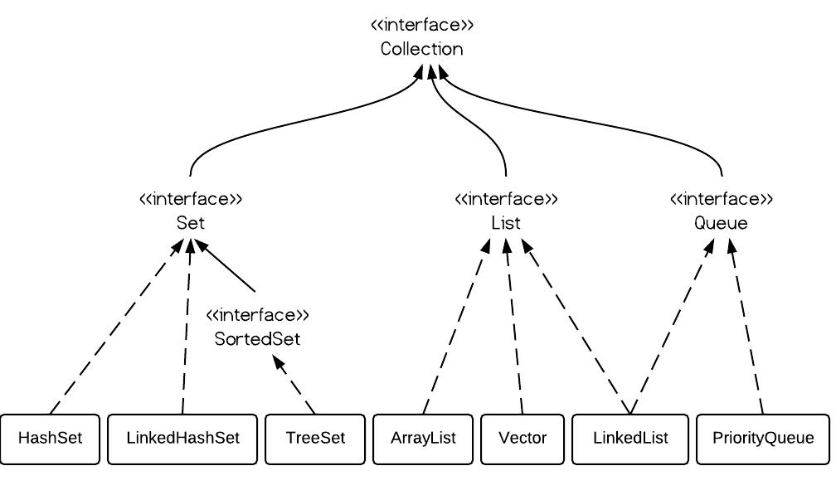

Map Interface Hierarchy:
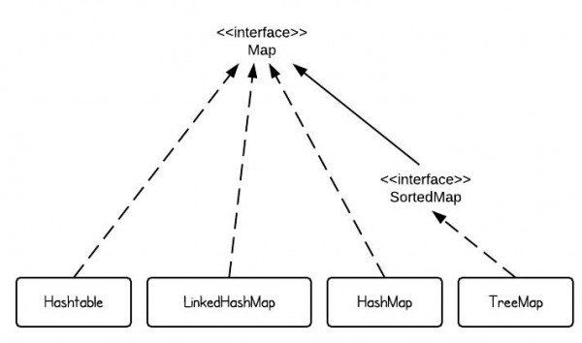
Map
- HashMap
- LinkedHashMap
- HashTable
SortedMap
- TreeMap

More Interfaces:
- NavigableMap
- NavigableSet
- Iterator
- ListIterator
- Enumeration
- Comparator
- Comparable

More Classes:
- Properties
- Collections
- Arrays
- ConcurrentHashMap
- CopyOnWriteArrayList
- CopyOnWriteArraySet
- WeakHasMap

What is Collection?
Collection framework is most used topic in java development. JDK 10 has also added few more methods.
A collection allows a group of object to be treated as a single unit. These objects can be stored, retrieved and manipulate as elements of collections.
Collection is used to perform some operation in the object. Collection has lots of predefined optimized methods that given us to perform our operations.
It also improve the performance, suppose we got some data from database and now again need to get new data by some kind of filtration like ordering, then we don’t need to go to database again, we can do searching sorting via collection.
Benefits of Java Collections Framework
Java Collections framework have following benefits:
- One common task on multiple objects. Suppose we have to serialize 50 objects then we have to call writeObject() 50 times but with the help of Collection we can call writeObject() only once and serialize the collection object.
- Detached Record set.
- Return any number of values from single function.
- Passing any number of argument on one function.
- Pooling
- Duplicacy Removing
- Sorting
- Searching
- Updation
- Serialization
- Cloning
- Reduced Development Effort:– It comes with almost all common types of collections and useful methods to iterate and manipulate the data. So we can concentrate more on business logic rather than designing our collection APIs.
- Increased Quality:– Using core collection classes that are well tested increases our program quality rather than using any home developed data structure.
- Re-usability and Interoperability
- Reduce effort:– No new to learn any new API if we use core collection API classes.
Collection is a first framework. It has created standard to perform operations. If we take example of photo frame then we can notice that frame designer never fix, what person photo should place there. He just make standard frame of size x and y. In Java we make standard via abstraction and collection does the same, it’s tasks varies user-to-user.

#. Some collections allow duplicate element and other do not. Some are ordered and others unordered.
#. All general purpose collection implementation classes should provide two standard constructors.
- clasName()
- className(Collection c): Suppose we have old collection and we are creating new collection and wants to give all old collection elements to new collection, then we can create collection with second constructor.
#. This collection frame is provided in java.util package and comprises of two main parts.
- The core interfaces that allow collection to be manipulated independently of their implementation.
- A small set of implementation that is concrete classes that are specific implementation of the core interfaces.
#. Differences on the basis of interfaces. It mean when to use which interfaces.
Interfaces | Description | Concrete Classes
Collection | A basic interface that defines the normal operation that allow a collection of object to be maintained or handled as a single unit.
Set: Unique elements and no order. | A set of unique elements. | Hash Set  LinkedHashSet
SortedSet: Unique elements but in sorted order. | A set in which elements are stored in some sorted order. | Tree Set
List: Duplicate elements but in insertion order. | A sequence of elements that not need to be unique. | ArrayList  VectorList  LinkedList
Map: Unique Keys, wants to store data with unique key so duplicate data will recognize. | A basic interface that defines operation for maintaining mappings of key to values. | HashMap  LinkedHashMap  HashTable
SortedMap: Unique keys but in sorted order. | This interface maintain their mapping sorted in key order. | Treemap

Methods of Collection Interface:
There are many methods declared in the Collection interface. They are as follows:
Method | Description
public boolean add(Object element) | If elements successfully added it returns true else false. This method is of collection so all child List and Set will have this method.
public boolean addAll(Collection c) | It is used to insert the specified collection elements in the invoking collection. To add one collection values to other collection.
public boolean remove(Object element) | It is used to delete an element from this collection.
public boolean removeAll(Collection c) | It is used to delete all the elements of specified collection from the invoking collection.
public boolean retainAll(Collection c) | It is used to delete all the elements of invoking collection except the specified collection.
public int size() | Return the total number of elements in the collection.
public void clear() | Removes the total no of element from the collection.
public boolean contains(Object element) | It is used to search an element. Check if any object is in collection
public boolean containsAll(Collection c) | It is used to search the specified collection in this collection.
public Iterator iterator() | Returns an iterator. Retrieve element one by one from any collection.
public Object[] toArray() | Converts collection into array. Returns all elements in the form of array.
public boolean isEmpty() | Checks if collection is empty.
public boolean equals(Object element) | Matches two collection.
public int hashCode() | Returns the hashcode-number for collection.

Iterator Interface
A collection framework provides an Iterator which allows sequential access to the elements of a collection. An iterator can be obtained by calling the following method of the collection interface.
- public Iterator iterator()
- public boolean hasNext(): Returns true if there are more elements otherwise returns false.
- public Object next(): Moves the iterator to the next element and returns the current element. Throws NoSuchElementException, if there is not a next element.
- Public Object remove(): Removes the element that was returned by last to the next() invoking this method result in an IllegalStateException, if the next() method has not yet be called.
(It only removes those elements that came from next() method).
#. Collection classes like ArrayList, Vector creates nested classes named “Itr” that implements Iterator interface. “Itr” class have methods like hasNext(), next()and etc. Collection classes have iterator() method that returns the object of Iterator. Same happens with ListIterator interface.

ListIterator Interface
ListIterator interface extends Iterator interface. This interface is a child of Iterator interface which allows programmer to traverse a list in inner direction and make modification to the underline list.
- public boolean hasNext()
- public boolean hasPrevious()
- public Object next()
- public Object previous()
- public int nextIndex(): It returns the index of next element in the list or size of list if there are no more elements.
Modification methods of ListIterator:
- public boolean add(Object o): Difference between Iterator add() and ListIterator add() is that it inserts the new Object immediately before the element which would be returned by the next() method.
- public Object remove()
- public void set(Object o): Replace the last elements in the list retrieved by a next() or previous() operation.

Enumeration Interface (From 1.2)
The Enumeration interface defines the method by which we can obtain (one at time) the elements in a collection of an object. The functionality of this interface is duplicated by the iterator interface.
Enumeration’s method public boolean hashMoreElemen() is same as Iterator’s hasNext().
public Object nextElement() is same as Iterator’s next() Method.

Difference between Iterator and Enumeration:
Enumeration | Iterator
It is a legacy interface which does not comes under the collection framework. | Whereas Iterator interface present in the collection interface.
All the legacy classes like Stack, Vector can use Enumeration. | The classes under the collection framework like ArrayList, LinkedList can use Iterator interface.
Enumeration an average performs above 50% faster than Iterator for sequential access of the collection elements.  Suppose two threads T1, T2 are sharing a common collection elements. If T1 updated the data then T2 won’t get the updated data because it does not check for any updation. | While Iteration process there are checks where the elements are undergoing, updating. So this is the reason for slowness.  But Iteration checks for every updation that’s why it is to slow.
Enumeration does not has remove() method. | Iterator has remove() method.
Enumeration is not Fail-Fast. | Iterator is Fail-Fast.

What is the meaning of Fail-Fast?
Suppose two threads T1, T2 are sharing a common collection elements. It T1 started to iterated and in middle sleeps then T2 will get chance. if data updated (add/remove) and then it fails and throw ConcurrentModificationException.

List Interface
Can put duplicate value also follows insertion orders.
#. All Collection methods came to List. List class has also overloaded many number of methods.
An Ordered Collection also known as sequence elements can be inserted or access by their position in the List using a 0 based index. A List may contain duplicate values, the position of an element can be changed as element are inserted or deleted from the List.
Methods:
- public void add (Integer index, Object go
- public boolean addOn (Integer index Collection c)
- public Object get (Integer index)
- public Object remove (Integer index)
- public Object set (Integer index, Object go)
- ListIterator listIterator()

IQ. Why Set class does not have listIterator() method but List Class have?
- Collection
  - List
    - ListIterator listIterator() method.
  - Set
    - Does not have listIterator() method.
Because Set class does not maintain orders. Elements come randomly so how we will know if we are going forward or backward so no sense to give this method in Set Class.

Collection | Ordering | Random Access | Key-Value | Duplicate Elements | Null Element | Thread Safety
ArrayList | Yes | Yes | No | Yes | Yes | No
LinkedList | Yes | No | No | Yes | Yes | No
HashSet | No | No | No | No | Yes | No
TreeSet | Yes | No | No | No | No | No
HashMap | No | Yes | Yes | No | Yes | No
TreeMap | Yes | Yes | Yes | No | No | No
Vector | Yes | Yes | No | Yes | Yes | Yes
Hashtable | No | Yes | Yes | No | No | Yes
Properties | No | Yes | Yes | No | No | Yes
Stack | Yes | No | No | Yes | Yes | Yes
CopyOnWriteArrayList | Yes | Yes | No | Yes | Yes | Yes
ConcurrentHashMap | No | Yes | Yes | No | No | Yes
CopyOnWriteArraySet | No | No | No | No | Yes | Yes

